Get Phone Location
Updated documents are always available at http://www.androidinspector.com/

Send SMS to Get Location
Send SMS #location to the target phone, then you will get a feedback SMS regarding the location(latitude, longitude) of it within about 2 minutes. It could be gotten by GPS, or WIFI connection, or base station according to the real situation.
Notice: the program will enable GPS on the phone and disable it after getting location. So do not worry about its security.

See Map
The returned location SMS contains latitude and longitude, for example:
Click the hyperlink to see map: http://maps.google.com/?q=39.905835,116.389396
You can click it to see in phone browser or copy latitude and longitude to PC browser to see the map.
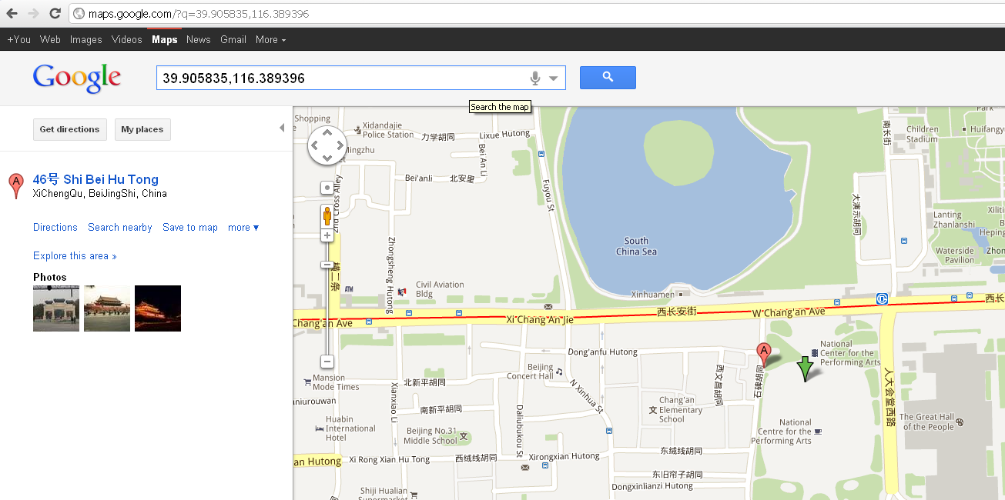
Latitude and Longitude
Notice: the accuracy of GPS is generally within 5~10 meters, and be within hundreds of meters if gotten by WIFI network or base station.

